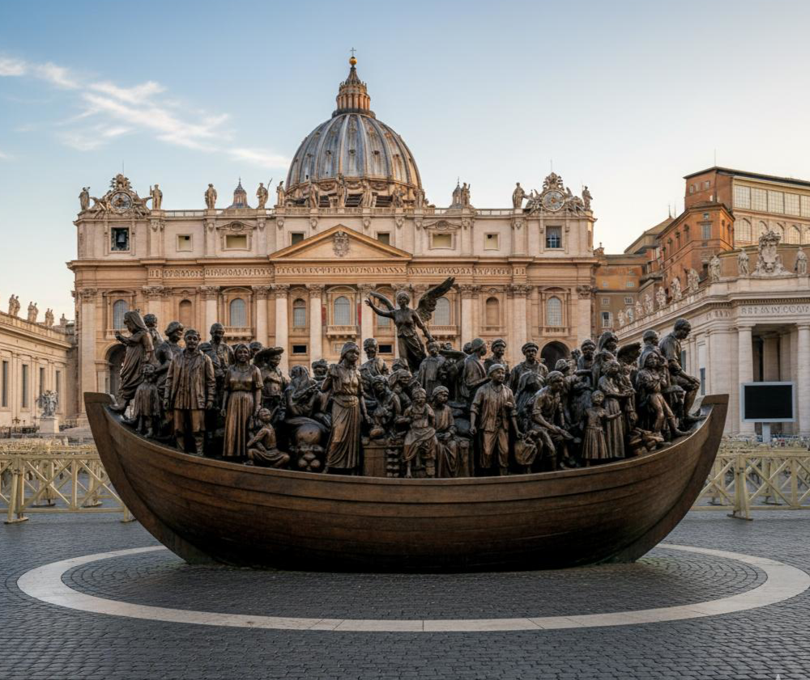
Our Inspiration

Why?
‘Angels Unawares’
A bronze sculpture in St. Peter’s Square, Vatican City
by Canadian artist Timothy Schmalz, installed in 2019

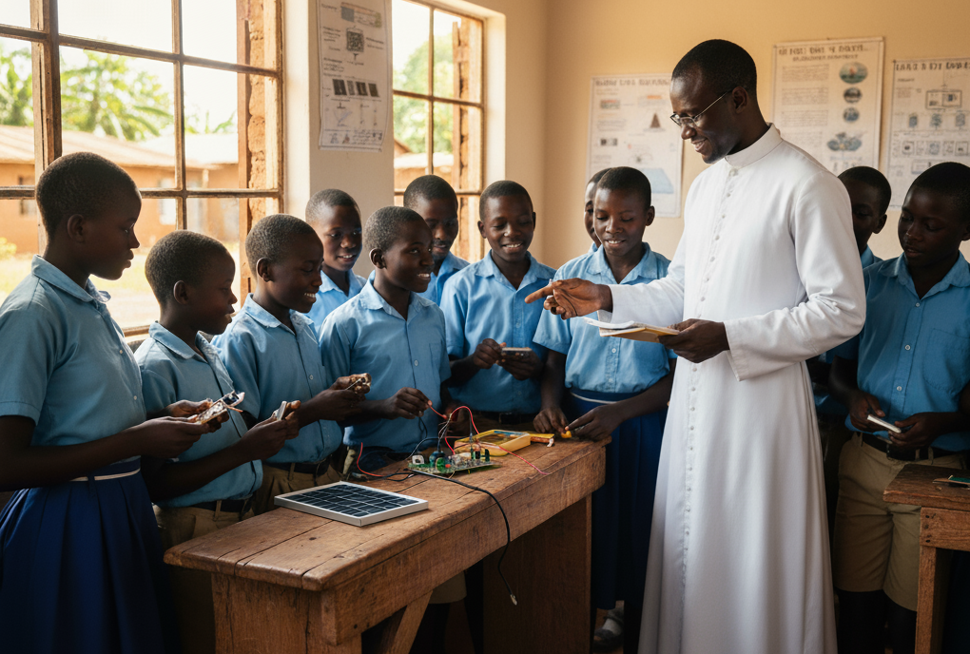

If only they are enlightened and empowered…
No more flight!
!

